PHASE III: REQUIREMENT ANALYSIS
Date | 05 November 2025
Team ID | NM2025TMID03595
Project Name | Garage Management Application
Maximum Marks | 4 Marks

Title: Requirement Analysis for “Garage Management Application – A Salesforce-Based Workshop Automation System”

1. Objective
The Requirement Analysis Phase focuses on identifying, defining, and validating the key business and technical requirements for developing the Garage Management Application on Salesforce.
This phase ensures that all functional and non-functional needs align with project goals—automating vehicle service operations, improving efficiency, and ensuring data accuracy across all modules.

2. Scope of the System
The Garage Management System is designed to streamline the workflow of automobile service centers by automating processes such as appointment booking, service tracking, billing, and customer feedback.

The scope includes:
- End-to-end management of customer, service, and billing records.
- Automation of appointment scheduling and service updates.
- Secure, role-based data access and sharing.
- Analytical dashboards for performance monitoring and decision-making
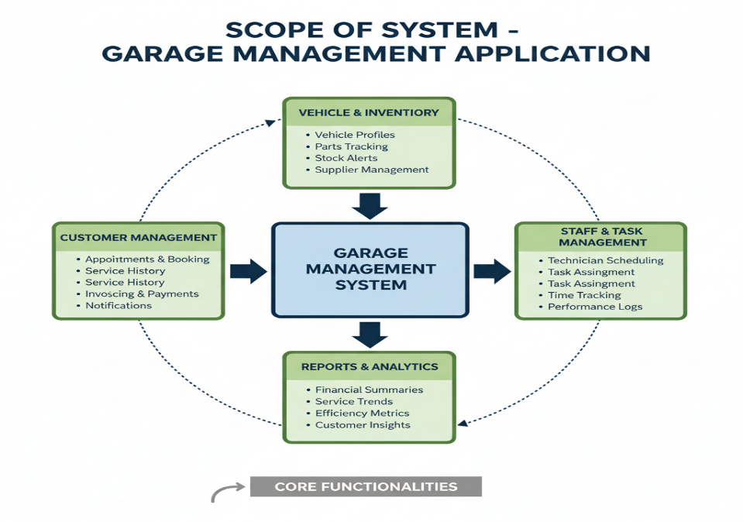

3. Functional Requirements

Functional requirements define how the system should operate within Salesforce.

3.1 Core Functional Modules
Module | Functionality | Salesforce Feature Used
Customer Management | Register customers, maintain contact info and vehicle details. | Custom Object + Lookup Relationship
Appointment Management | Schedule and track vehicle servicing appointments. | Custom Object + Validation Rules
Service Records Management | Maintain service details, parts replaced, and completion status. | Custom Object + Flows
Billing & Feedback | Manage payment status and record customer feedback. | Picklist + Validation Rule + Flow
Dashboard & Reporting | Monitor overall workshop performance and service analytics. | Reports + Dashboards

3.2 System Workflow
- Customer books an appointment for a vehicle service.
- System automatically logs appointment details and calculates service amount via Apex Trigger.
- Technician updates service record status upon completion.
- Billing record and customer feedback are generated automatically.
- Manager reviews dashboards for daily performance and pending tasks.

4. Technical Requirements
The technical setup ensures a robust Salesforce implementation.
Category | Requirement | Description
Platform | Salesforce Developer Edition | Cloud-based CRM for automation and data management
Programming | Apex (Trigger)
  Automates service amount distribution
Automation Tool | Salesforce Flow | Updates payment and service status automatically
Database | Salesforce Objects | Stores structured service and billing data
Visualization | Dashboards & Reports
  Monitors workshop KPIs and customer satisfaction
Security | Profiles, Public Groups, and Sharing Rules | Ensures proper access control by user role

4.1 Software Tools
- Salesforce Lightning Experience
- Flow Builder
- Schema Builder
- Developer Console
- Dashboard & Report Builder

4.2 Hardware Requirements
Component | Minimum Specification
Processor | Intel i3 or higher
RAM | 4 GB minimum
Storage | 512 MB browser cache space
Internet | Stable 2 Mbps connection
Browser | Google Chrome or Microsoft Edge (latest)

5. Non-Functional Requirements
These requirements define system performance, usability, reliability, and security characteristics.
Category | Requirement | Description
Performance | Handle 100+ concurrent user operations | Supported by Salesforce Cloud architecture
Scalability | Should accommodate multiple branches or workshops | Achieved through modular data design
Security | Enforce data privacy via roles | Controlled using Profiles and Role Hierarchy
Usability | Simple, intuitive interface for users
  Implemented using Lightning App UI
Reliability | 99.9% uptime | Ensured by Salesforce platform reliability
Maintainability |  | Achieved via declarative (low-code) tools
  Easy to enhance and debug

6. Data Model Design
The Data Model defines object relationships and dependencies for the system.
Object | Key Fields | Relationship Type
Customer Details | Name, Phone, Email | Lookup to Vehicle Details
Appointment | Date, Service Type, Vehicle Number
  Lookup to Customer Details
Service Records | Service Status, Quality Check
  Master-Detail with Appointment
Billing Details & Feedback
  Payment Status, Rating for Service
  Lookup to Service Records

Formula Used:
For automatic service amount calculation :
IF(Maintenance_service__c && Repairs__c && Replacement_Parts__c, 10000,
IF(Maintenance_service__c && Repairs__c, 5000,
IF(Maintenance_service__c && Replacement_Parts__c, 8000,
IF(Repairs__c && Replacement_Parts__c, 7000,
IF(Maintenance_service__c, 2000,
IF(Repairs__c, 3000,
IF(Replacement_Parts__c, 5000, 0)))))))

7. User Interface (UI) Requirements
The Lightning App Interface ensures easy navigation and quick access to essential records.

Tabs Included:
- Home
- Customer Details
- Appointments
- Service Records
- Billing Details & Feedback
- Reports & Dashboards

7.1 UI Expectations
- Clean and user-friendly layout
- Flows for quick record creation
- Responsive on desktop and mobile
- Dashboards embedded in the homepage for live updates

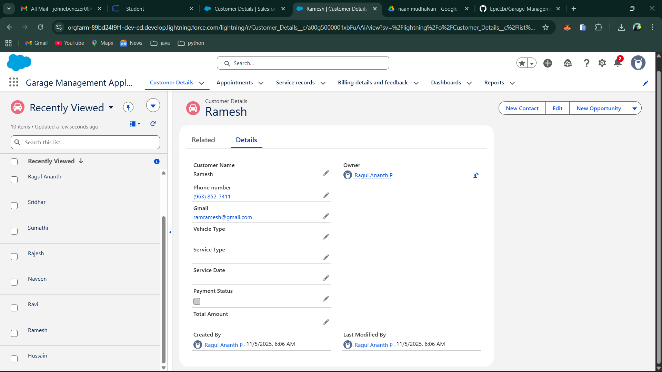

8. System Validation Requirements
Test Area | Description | Expected Output
Flow Execution | Payment update flow runs successfully | Payment updated automatically
Trigger Validation | Service amount calculated correctly | Amount reflected in Appointment record
Dashboard Display | Report updates reflect real-time data | Charts refresh instantly
Profile Access | Manager vs Salesperson access verification | Role-based access confirmed

9. Risk Identification and Mitigation
Risk | Description | Mitigation Strategy
Data Deletion | Accidental record removal | Enable Recycle Bin & backup policies
Access Issues | Improper role assignments | Conduct periodic permission audits
Automation Error | Flow or trigger logic failure | Implement debug logs and test runs
Network Downtime | Dependency on internet access | Export key reports for offline use

10. Summary
The Requirement Analysis Phase defines the functional and technical blueprint for the Garage Management Application.
All modules, workflows, and relationships were identified and validated to ensure smooth integration during implementation.

Key Achievements:
- Complete mapping of service and billing modules
- Automation and validation rules finalized
- Defined security and access models
- Identified scalability and performance benchmarks
This phase establishes a clear roadmap for the upcoming Design and Implementation Phases, ensuring the system is efficient, secure, and user-friendly.

